**0MODULE-3**

**CORROSION AND ELECTRODE SYSTEM**

**CORROSION CHEMISTRY**

**Definition of corrosion:** Corrosion is defined as the destruction of metals or alloys by the surrounding environment through chemical or electrochemical reactions

Example: When iron is exposed to air in the presence of moisture, hydrated ferric oxide (rust) is formed. s

**Electrochemical theory of corrosion taking iron as an example:** According to electrochemical theory, corrosion of metals takes place due to the formation of anodic and cathodic regions on the same metal surface or when two different metals are in contact with each other in the presence of a conducting medium.

**Reactions:**

**Reaction at anodic region:** Oxidation of metal takes place at anode. Metal atoms are converted into their ions liberating electrons. Consequently, metal undergo corrosion at the anodic region.

OH- OH-

Fe2+ Fe2+

Iron Metal

O2

H2O

Electrons

Cathodic region

Anodic region

e.g. Fe Fe2+ + 2 e-

**Reactions at cathodic region:** At the cathodic region reduction reaction takes place. Since the metal cannot be reduced further, metal atoms at the cathodic region are unaffected by the cathodic region. Some constituents of the corrosion medium take part in the cathodic reaction.

a) Liberation of hydrogen (in the absence of oxygen)

In acidic medium the reaction is

2 H+ + 2 e- H2

In neutral or alkaline medium, the reaction is

2 H2O + 2 e- 2 OH- + H2

b) Absorption of oxygen (in the presence of oxygen)

In acidic medium, the reaction is

4 H+ + O2 + 4 e- 2 H2O

In neutral or alkaline medium, the reaction is

2 H2O + O2 + 4 e- 4 OH-

**Overall reaction:**

The electrons liberated at the anodic region migrate to the cathodic region constituting corrosion current. The Fe2+ ions liberated at the anode and OH- ions formed at the cathode diffuse towards each other. Since smaller Fe2+ ions diffuse more rapidly than OH- ions, their combination occurs more commonly near the cathodic region produces Fe(OH)2. Corrosion of metal continues as long as both anodic and cathodic reactions takes place simultaneously.

Fe2+ + 2 OH- Fe(OH)2

2 Fe(OH)2 + 1/2 O2 + H2O Fe2O3 . 3 H2O (yellow rust is formed in an oxidising environment)

3 Fe(OH)2 + 1/2 O2 Fe3O4 . 3 H2O (black rust is formed in presence of limited oxygen)

**Types of corrosion:**

1. **Differential metal /Galvanic corrosion:**

Zn metal

Fe metal

Fe metal

Cu metal

Anode Cathode Anode Cathode

This type of corrosion occurs when two dissimilar metals are in contact with each other and are exposed to a corrosive environment. The two metals differ in their electrode potentials. The metal with lower electrode potential acts as anode and the other metal with higher electrode potential acts as cathode.

The anodic metal undergoes oxidation and gets corroded. A reduction reaction occurs at the cathodic metal. The cathodic metal does not undergo corrosion.

The reactions may be represented as follows:

At anode: M Mn+ + n e-

At cathode: 2 H2O + O2 + 4 e- 4 OH-

Higher the potential difference between the anodic and cathodic metals, higher is the rate of corrosion. Also on the ratio of anodic area to cathodic area, environmental factors, tendency of metal to exhibit passivity.

**Example:** When iron is in contact with zinc, iron acts as cathode and zinc acts as anode because zinc has lower electrode potential compared to iron. Therefore, zinc undergoes corrosion. On the other hand, when iron is in contact with tin, iron acts as anode because iron has lower electrode potential compared to tin. Hence iron undergoes corrosion.

Other examples:

1. Steel screws in copper sheet.
2. Steel screws with copper washer.
3. Bolt and nut made of different metals

**2.** **Differential aeration corrosion:**

This type of corrosion occurs when two different parts of the same metal are exposed to different oxygen concentrations. (e.g. An iron rod partially dipped in water.) The part of the metal which is exposed to less oxygen concentration acts as anode. The part which is exposed to more oxygen concentration acts as cathode. The anodic region undergoes corrosion and the cathodic region is unaffected.

The reactions may be represented as follows:

At anode: M Mn+ + n e- (Oxidation of M)

At cathode: 2 H2O + O2 + 4 e- 4 OH- (Reduction of O2

Other examples:

1. Part of the nail inside the wall undergoes corrosion.
2. When a dirt particle sits on a metal bar, the part under the dirt undergoes corrosion.
3. Partially filled iron tank undergoes corrosion inside water.

**Pitting corrosion:** This is an example of differential aeration corrosion. When a small dust particle gets deposited on a steel surface, the region below the dust particle is exposed to less oxygen compared to the remaining part. As a result, the region 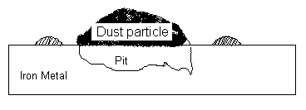below the dust particle acts as anode undergoes corrosion and forms a pit. The remaining region of the metal acts as cathode and is unaffected.

The reactions may be represented as follows:

At anode: M Mn+ + n e-

At cathode: 2 H2O + O2 + 4 e- 4 OH-

Formation of a small anodic area and a large cathodic area results in intense corrosion below the dust particle.

**Water line corrosion:** This is an example of differential aeration corrosion. When a steel tank is partially filled with water for a long time, the inner portion of the tank below the water line is exposed only to dissolved oxygen, whereas, the portion above the water line is exposed to more oxygen. Thus the portion below the water line acts as anode and undergoes corrosion. The upper portion acts as cathode and is unaffected.

A distinct brown line is formed just below the water line due to the deposition of rust.

The reactions may be represented as follows:

At anode: M Mn+ + n e- (Oxidation of metal, M)

At cathode: 2 H2O + O2 + 4 e- 4 OH- (Reduction of oxygen)

Other example: Ships which remain partially immersed in sea water for a long time undergo water line corrosion.

**Corrosion control**

**METAL COATINGS**

Metallic coatings are applied on a metal in order to protect metal from corrosion.

**Galvanizing:** Galvanizing is the process of coating a metal surface such as iron with zinc metal. Galvanizing of iron is an example of anodic metal coating on the surface of a cathodic metal.

**Process:** Galvanization is carried out by hot dipping method. It involves the following steps

1. The metal surface is washed with organic solvents to remove organic matter on the surface.
2. Rust is removed by washing with dilute sulphuric acid.
3. Finally, the article is washed with water and air-dried.
4. The article is then dipped in a bath of molten zinc. (Molten zinc is covered with a flux of ammonium chloride to prevent the oxidation of molten zinc.)
5. The excess zinc on the surface is removed by passing through a pair of hot rollers.

Application: Galvanization of iron is carried out to produce roofing sheets, fencing wire, buckets, bolts, nuts, pipes etc.

(Note: Even if the Zn coating falls off at some places, the base metal (Fe) does not get corroded at those places. (This is because the base metal acts as cathode. In corrosion process, the cathodic metal always remains unaffected.) And because of the formation of small cathodic area and larger anodic area corrosion process will not be there.

(Note: Galvanized articles are not used for preparing and storing food because zinc dissolves in dilute acids producing toxic zinc compounds).

**INORGANIC COATING**

**Anodizing** (Anodizing of aluminum): When aluminum metal is made anodic in an electrolytic bath with sulphuric acid or chromic acid as the electrolyte, a thin layer of aluminium oxide (Al2O3) is formed on the surface. This process is called anodizing of aluminium or anodic oxidation of aluminum.

**Process:** The article is subjected to decreasing and polishing and then made as anode. Chromic acid electrolyte is maintained at about 350C and suitable voltage is maintained to get desired thickness of the oxide film. After anodizing it is subjected to sealing which involves heating with boiling water or steam. When anodized aluminium is exposed to a corrosive environment, the Al2O3 layer on the surface acts as a protective coating. Hence corrosion is prevented.

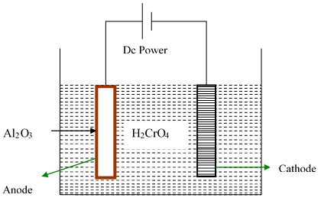

Anode reaction: 2Al + 3H2O → Al2O3 + 6H+ +6e-

Cathode reaction: 6H+ + 6e- → 3H2

Net reaction: 2Al + 3H2O → Al2O3 + 3H2

Other metals such as Mg, Ti etc. can also be anodized.

(Note: On anodizing, Al2O3 is formed on the surface as a porous layer. The layer may be made compact by sealing, which involves heating with boiling water or steam. During sealing, Al2O3 is converted into Al2O3.H2O which occupies higher volume. Therefore, the pores are sealed.)

Applications: Metals such as Al, Mg, Ti etc. are anodized to control corrosion.

**CATHODIC PROTECTION**

**Sacrificial anode method:**

In cathodic protection, the metal to be protected is completely converted into a cathode. Since cathodes do not undergo corrosion, the metal is protected against corrosion, by connecting auxiliary anode which is more active metal such as Al, Mg, or Zn.

In sacrificial anode method, the metal to be protected is electrically connected to a more active metal. For example, when steel is to be protected, it may be connected to a block of Mg or Zn. In such a situation, steel acts as cathode and is unaffected. Mg and Zn act as anode and undergo sacrificial corrosion. When the sacrificial anode gets exhausted, it is replaced with new ones.

Other examples: Mg bars are fixed to the sides of ships to act as sacrificial anode.

Mg blocks are connected to buried pipe lines.

Mg blocks are connected to buried oil storage tank.

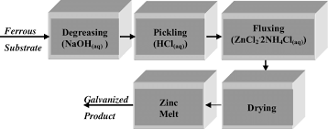

Galvanization diagram.

**Corrosion Penetration Rate (CPR)**

Corrosion Penetration Rate (CPR) is defined as the amount of corrosion lost per year in thickness. Mathematically,

CPR= $\frac{KW}{ρAt}$

The CPR is conveniently expressed in terms of either mils per year (mpy) or millimeters per year (mm/yr)

Where, 1 mil =0.001 inch

|  |  |  |
| --- | --- | --- |
|  | CPR in mpy | CPR mm/yr |
| K | 534 | 87.6 |
| W(wt loss) | mg | Mg |
| ρ | g/cc | g/cc |
| A | inch2 | cm2 |
| t | hrs | Hrs |

Problems:

1. A sheet of carbon steel one-meter-wide by three meters long has lost 40g to corrosion over the past six months. Convert that mass loss to a penetration rate of the steel in mm units and mpy units. What would be the corrosion rate? (Carbon steel density=7.8g/cc)

To calculate CPR in mm/yr

|  |  |  |
| --- | --- | --- |
|  | Given | CPR mm/yr |
| K |  | 87.6 |
| W | 40g | 40X1000 mg |
| ρ | 7.8g/cc | 7.8 g/cc |
| A | 1mx3m=3m2 | 3x100X100 cm2 |
| t | 6 months | 6x30X24 hrs |

CPR=

CPR= $\frac{87.6X40X1000mg}{7.8\frac{g}{cc}X3x100X100{cm}^{2}X6x30X24hrs}$ = 3.466 X10-3 mm/yr

CPR= 0.003466mm/yr

To calculate CPR in mpy

|  |  |  |
| --- | --- | --- |
|  | Given | CPR in mpy |
| K |  | 534 |
| W | 40g | 40 x 1000 mg |
| ρ | 7.8g/cc | 7.8 g/cc |
| A | 1mx3m=3m2 | 3 x1550 inch2 |
| t | 6 months | 6 x 30 x 24 hrs |
|  |  |  |

1 sq mt (m2) = 1550 sq inch

CPR= $\frac{KW}{ρAt}$ CPR= $\frac{534X40X1000mg}{7.8\frac{g}{cc}X3x1550{}^{2}X6x30X24hrs}$ = 0.1363mpy

2. A piece of corroded steel plate was found in a submerged ocean vessel, it was estimated that the original area was 10in2 that approximately 2.6kg had corroded away during the submersion. Assuming a corrosion penetration rate of 200mpy for this alloy in sea water, estimate the time in years, density of steel 7.9g/cc.

|  |  |  |
| --- | --- | --- |
|  | Given | CPR in mpy |
| K |  | 534 |
| W | 2.6kg | 2.6 x 1000 x1000 mg |
| ρ | 7.9g/cc | 7.9 g/cc |
| A | 10 inch2 | 10 inch2 |
| t | X | X hrs |

CPR= and t= $\frac{KW}{ρAcpr}$

t= $\frac{534X2.6X{10}^{6}mg}{7.9g/{ccX}10{}^{2}X200mpy}$ t= 87873.41hrs

t=

3. Calculate the CPR in both mpy and mm/yr for a thick steel sheet of area 100 in2 which experiences a weight loss of 485g after one year. (density of steel=7.9g/cm3).

|  |  |  |
| --- | --- | --- |
|  | Given | CPR in mpy |
| K |  | 534 |
| W | 485g | 485 x1000 mg |
| ρ | 7.9g/cc | 7.9 g/cc |
| A | 100 in2 | 100 inch2 |
| t | 1 yr | 365 X 24 hrs |

CPR= $\frac{KW}{ρAt}$ CPR= $\frac{534X485X1000mg}{7.9\frac{g}{cc}X100{}^{2}X365X24hrs}$

CPR=37.424mpy

|  |  |  |
| --- | --- | --- |
|  | Given | CPR in mm/y |
| K |  | 87.6 |
| W | 485g | 485 x1000 mg |
| ρ | 7.9g/cc | 7.9 g/cc |
| A | 100 in2 | 100 x 6.45cm2 |
| t | 1 yr | 365 x 24 hrs |

1 in2 = 6.45cm2

1 cm2= 0.155 in2

CPR= CPR= $\frac{87.6X485X1000mg}{7.9\frac{g}{cc}X100X6.45{cm}^{2}X365X24hrs}$ =0.9518mm/y

**ELECTRODE SYSTEM**

TYPES OF ELECTRODES

1.METAL METAL ION ELECTRODE

Eg: Zn/Zn 2+, Cu/Cu2+

2.METAL METAL SALT ION ELECTRODE

Eg: Calomel Electrode(Hg/Hg2Cl2/Cl--)

Silver –Silver chloride electrode (Ag/AgCl/Cl--)

3. GAS ELECTRODE

Eg: Hydrogen Electrode (Pt/H2/H+)

4. OXIDATION REDUCTION ELECTRODE

Eg: Pt/Fe2+ /Fe3+

5. ION SELECTIVE ELECTRODE

Eg: Glass electrode

***Reference Electrode:***

Definition: Reference electrodes are the electrodes with reference to those, the electrode potential of any electrode can be measured. They are of two types; Primary reference electrode (eg: SHE) and secondary reference electrode.

**SECONDARY REFERENCE ELECTRODES:**

Secondary reference electrodes are the electrodes with reference to those, the electrode potential of any electrode can be measured.

Examples**:** 1.Calomel electrode 2. Ag-AgCl electrode

**Calomel electrode:** It is a metal-metal salt ion electrode

It consists of mercury, mercurous chloride and a solution of KCl. Mercury is placed at the bottom of a glass tube. A paste of mercury and mercurous chloride is placed above the mercury. The space above the paste is filled with a KCl solution of known concentration. A platinum wire is kept immersed into the mercury to obtain electrical contact.

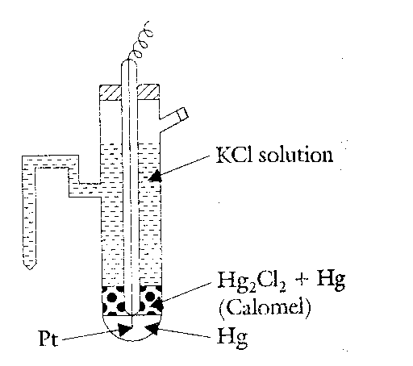

Calomel electrode can be represented as, Hg| Hg2Cl2|Cl-.

The calomel electrode can acts as anode or cathode depending on the nature of the other electrode of the cell.

When it acts as anode, the electrode reaction is,

2Hg Hg22+ + 2e-

Hg22+ + 2Cl-  Hg2Cl2

2Hg + 2Cl- Hg2Cl2 + 2e-

When it acts as cathode, the electrode reaction is,

Hg22+ + 2e-  2Hg

Hg2Cl2 Hg22+ + 2Cl-

Hg2Cl2 + 2e-  2Hg + 2Cl-

The net cell reversible electrode reaction is,



Electrode potential, $E=E^{0}−\frac{2\text{.}\text{303}\text{RT}}{\text{nF}}\text{.}\text{log}{\left[{\text{Cl}}^{−}\right]}^{2}$

$E=E^{0}−\frac{2\text{.}\text{303}\text{RT}}{F}\text{.}\text{log}\left[{\text{Cl}}^{−}\right],$ Where n=2

$E=E^{0}−0\text{.}\text{0591}\text{.}\text{log}\left[{\text{Cl}}^{−}\right]$ at 298K

Therefore, electrode potential of calomel electrode is depending upon the concentration of KCl.

For saturated KCl, the potential is +0.242V, for 1N and 0.1N KCl the values are 0.281V and +0.334V respectively.

***Applications:***

1***.***It is used as secondary reference electrode in the measurement of single electrode potential

2. It is used as reference electrode in all potentiometer determinations

3**.** It is used as a secondary reference electrode in place of calomel electrode / glass electrode /

ion selective electrodes.

4. Used in determining whether the potential distribution is uniform or not in ship hulls and old pipelines protected by cathodic protection.

5. As a portable reference electrode for measuring the different depths of oil rigs and platforms, submerged oil pipelines etc. usually such probe is powered by Ni – Cd battery and can operate up to a depth of 300-400m with precision of 1mv.

**Ion selective electrode:** Definition: “Ion selective electrode is one which selectively responds to a specific ion in a mixture and the potential developed at the electrode is a function of the concentration of that ion in the solution”

**Glass electrode:** A glass electrode is an ion selective electrode where potential depends upon the pH of the medium.

The glass electrode consists of a glass bulb made up of special type of glass (22 % Na2O) which has low melting point and relatively high electrical conductivity. The glass bulb is filled with a solution of constant pH (0.1MHCl) and inserted with a Ag-AgCl electrode, which is the internal reference electrode and also serves as the external electrical contact. The electrode dipped in a solution containing H+ ions.

The electrode representation is Ag(s) |AgCl | 0.1M HCl| Glass

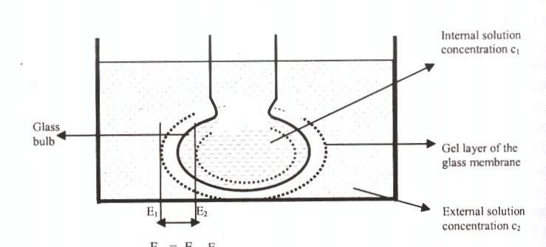

H+ Ion Solution

Ag-AgCl electrode

0.1 M HCl

Glass electrode

#### Working

#### The boundary potential is given by Nernst equation at membrane Eb = Ec – Ea

Therefore Eb = [E˚+0.0591 log C1] – [E˚+0.0591 log C2]

Eb = 0.0591 log C1 – 0.0591 log C2

Eb = K + 0.0591 log [C1] const. K= - 0.0591 log[C2]

**Eb = K – 0.0591pH** since C1=[H+] and pH= - log [H+]

Therefore EG = Eb + EAg/AgCl +Easym

EG = K – 0.0591pH + EAg/AgCl +Easy

**EG= E˚G – 0.0591pH**  where E˚G = K+ EAg/AgCl +Easy

#### Advantages

1. This electrode can be used to determine PH in the range 0-9, with special type of glass even up to 12 can be calculated.

2. It can be used even in the case of strong oxidizing agents.

3. The equilibrium is reached quickly.

4. It is simple to operate, hence extensively used in various laboratories.

#### Limitations

1. The glass membrane though it is very thin, it offers high resistance. Therefore ordinary potentiometers cannot be used; hence it is necessary to use electronic potentiometers.

2. This electrode cannot be used to determine the PH above 12

**Determination of pH using glass electrode:**

***Principle:*** When a thin glass membrane is placed between two solutions of different pH values, a potential difference arises across the membrane. The potential difference varies as the pH of these solutions varies. In practice, pH of one of these solutions is kept constant and therefore the electrode potential depends on pH of the other solution i.e experimental solution.

pH Meter

Calomel

electrode

Glass

electrode

Solution of

unknown pH

***Procedure:*** Glass electrode is immersed in the solution whose pH is to be determined. It is combined with a reference electrode such as a calomel electrode (through a salt bridge= porous disc). The cell assembly is represented as,

Hg(Ɩ)| Hg2Cl2|Cl-||Solution of unknown pH|Glass|0.1M HCl |AgCl |Ag(s)

The emf of the above cell, Ecell is measured using an electronic voltmeter with a pH meter.

The emf of the cell is given by

**E cell=E Cathode- E anode**

E cell = E˚G – 0.0591pH -ESCE

pH = E˚G –ESCE – Ecell

----------------------------------

0.0591

**Concentration cells:** A concentration cell is an electrochemical cell in which the electrodes and the electrolyte solutions in both the half cells are composed of the same element/substance/material, but only the concentrations of the two electrolyte solutions are different.

**Construction:** A typical example of Zinc concentration cell is shown below.

Salt bridge

+

-_

**e-**

Zinc

Cathode

Zinc

Anode

ZnSO4

Solution

ZnSO4

Solution

C1

C2

It consists of two zinc electrodes are immersed in two different concentrations of ZnSO4 solutions. These two electrodes are externally connected by metallic wire and internally by a salt bridge. The cell can be represented as,

Zn(s) |Zn2+ (C1) || Zn2+ (C2) | Zn(s)

By convention left hand electrode is the anode and right hand electrode is cathode.

**Working:**



The net cell reaction is merely the change in concentration as a result of current flow.

***Emf of concentration cell:***

We know that electrode potential depends upon the concentration of the electrolyte. By convention, the potential of the cell is

Ecell = Ecathode - Eanode ………..1

Ecell= $\frac{0\text{.}\text{0591}}{n}\text{log}\left[C2\right]−\frac{0\text{.}\text{0591}}{n}\text{log}\left[C1\right]$………2

$E_{\text{cell}}=\frac{0\text{.}\text{0591}}{n}\text{log}\frac{\left[C_{2}\right]}{\left[C_{1}\right]}$ at 298K ………3

From equation (3) following conclusions may be drawn.

1. When the two solutions are of the same concentration, then $\text{log}\frac{\left[C_{2}\right]}{\left[C_{1}\right]}$ and no electricity flows. Hence, Ecell = 0

2. When C2/C1>1 ic C2>C1, log C2/C1 is positive & electrode potential is positive.

3. Higher the ratio of C2/C1, higher is the value of cell potential.

**Numerical Problems:**

1. Calculate the emf of copper concentration cell at 250C, the copper ions ratio in the cell is 10.

Given: $\frac{[{\text{Cu}}^{+2}]_{\text{cathode}}}{[{\text{Cu}}^{+2}]_{\text{anode}}}=\frac{C_{2}}{C_{1}}=\text{10}$

w.k.t $E_{\text{cell}}=\frac{0\text{.}\text{0591}}{n}\text{log}\left(\frac{C_{2}}{C_{1}}\right)$; at 298 K

$$E_{\text{cell}}=\frac{0\text{.}\text{0591}}{2}\text{log}(\text{10})$$

Ecell = 0.0296 V.

2. A concentration cell was constructed by immersing two silver electrode in 0.05M and 1M AgNO3 solution. Write the cell representation, cell reactions and calculate the EMF of the cell.

Cell representation: Ag(s)AgNO3(0.05M) AgNO3(1M) Ag(s)



Ecell = 0.0768V

3. The spontaneous galvanic cell Tin/Tin ion(0.024M)//Tin ion(0.064M) /Tin develop an emf of 0.0126 V at 25OC, Calculate the Valency of Tin.

$$E_{\text{cell}}=\frac{0\text{.}\text{0591}}{n}\text{log}\left(\frac{C_{2}}{C_{1}}\right)$$

$$n=\frac{0\text{.}\text{0591}}{E_{\text{cell}}}\text{log}\left(\frac{C_{2}}{C_{1}}\right)$$

$$n=\frac{0\text{.}\text{0591}}{0\text{.}\text{0126}}\text{log}\left(\frac{0\text{.}\text{064}}{0\text{.}\text{024}}\right)$$

n =2(Valency of tin)

**ANALYTICAL TECHNIQUES**

1. **CONDUCTOMETRY**

It is an electrochemical method of analysis used for the determination or measurement of the electrical conductance of an electrolyte solution by means of a conductometer.

Conductometry means measuring the conductivity of an ionic solution

Conductance is ease with which current flows through the solution. It is reciprocal of resistance.

C=1/R (Unit is Ω-1 or mho or Siemens)

The conductance of the solution is explained by considering ohm’s law.

According to ohm’s law the current flowing through the conductor is directly proportional to voltage an inversely proportional to the resistance. I = V/ R

The resistance of the any conductor is directly proportional to the length and inversely proportional to the area of cross section of the conductor. R α l/a

R = S (l/a) where S is specific resistance

Therefore 1/S = 1/R (l/a);

K = C (l/a), K = specific conductance, Specific conductance is also called conductivity. It is the conductance of 1cm3 of solution.

It is defined as the conductance of the solution which is place between two electrodes of area 1cm2 and 1cm apart.

The conductance of the solution depends on mobility of ion, number of ion, charge of ion, size of ion and temp.

**Types of conductance:**

**Specific conductance (K)** is conductance of the solution which are placed between two electrodes of area 1cm2 and at 1cm apart

κ = 1/R (l/a) κ = Siemen m-1

**Equivalence conductance (λ)** is the conductance of the solution when 1g equivalent weight of solution is placed between two electrodes of area 1cm2 at 1cm apart.

**Molar conductance (µ)** is the conductance of the solution when 1g molecular weight of solute is placed between two electrodes of area 1cm2 at 1cm apart

**Weak acid v/s Strong base**

CH3COOH against NaOH

CH3COOH + NaOH CH3COONa + H2O

The conductance of the acid will be initially low since acetic acid is a weak electrolyte. When NaOH is added to the acid, the salt formed is highly ionized and the conductance increases. On complete neutralization of the acid, further addition of base leads to increases in the number of mobile OH- ions. Hence the conductance increases sharply. A plot of conductance against the volume of base added is shown in the figure. The point of intersection of two curves gives the endpoint.

|  |  |
| --- | --- |
| Volume of NaOH | Conductance |
|  |  |

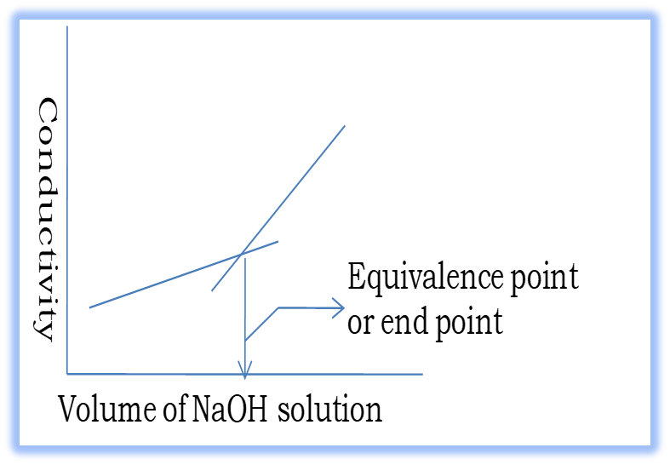

**Advantages:**

* Mixture of acid can be titrated
* Indicators are not used
* Very weak acids can be titrated
* Can be used with colored solution.

1. **POTENTIOMETRY**

A method of determination of the concentration of a solution by measuring EMF using potentiometer is called Potentiometry.

**Principle:** Redox titrations can be carried out potentiometrically using platinum and calomel electrode combination in a manner similar to acid-base neutralizations.





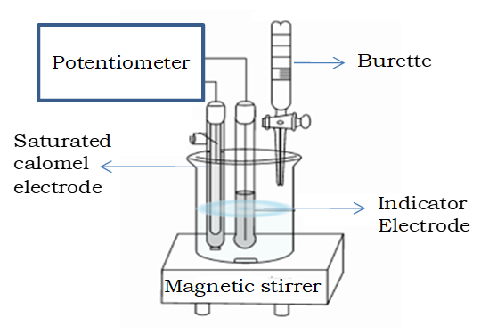

**Instrumentation**





 